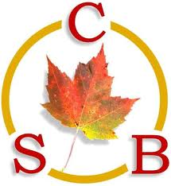
CANADIAN BIOMATERIALS SOCIETY
SOCIÉTÉ CANADIENNE DES BIOMATÉRIAUX

WBC2020 Trainee Travel Award Adjudication Form

If you have an accepted oral or poster presentation at the WBC 2020, please complete this form and submit to nima.khademmohtaram@uwaterloo.ca no later than January 15, 2020 midnight (EST)

- Name of Trainee:

- Trainee Home Institution (University):

- Primary Supervisor(s):

- Trainee Category (circle one of the following): PDF/PhD/Masters

How long have you been a trainee in this category? Years Months

- WBC2020 Accepted Abstract: Oral Poster (please attach the e-mail confirmation from WBC2020)

- If you published peer-reviewed journal articles, please list a maximum of 3:

P1.

P2.

P3.

- Trainee Signature:

- Supervisor Signature:

